Document Convention

Author: Peter

Responsible: Peter

Description: <https://learnit.itu.dk/mod/page/view.php?id=186418>

For our documents I have set up a folder structure that includes pre-made documents for all future scheduled tasks in the project. It currently looks like this:

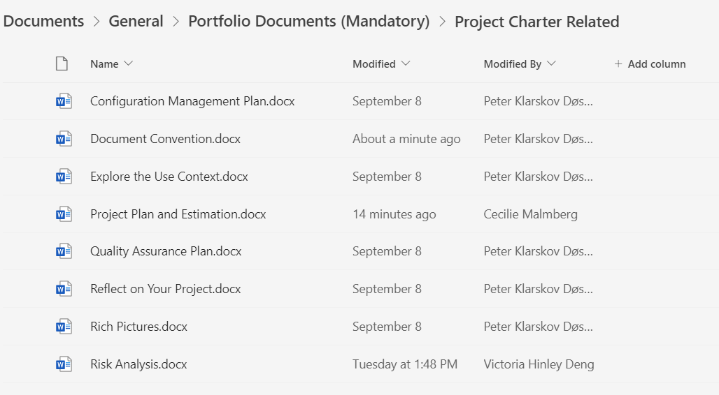

These documents contain meta-data for their respective author and responsible individual. For version control we have been backing up our documents in a private GitHub repository since week 1, ensuring that we have access to earlier versions of all documents in case of file corruption, user error resulting in unintentional deletion or change of documents, and also in case we want to revert to a previous version of our documents.

The structure itself also has an archive folder. The archive folder is meant for documents that are only in use temporarily and then discarded, but kept in case we need information or documentation from them.

Instead of employing a traditional changelog in the style of a text file for our documents, we use the tasks on our Trello board to note significant changes. This allows us to compare the document changes in the repository with their appertaining Trello task-changelog on a week to week basis.

Finally, documents are named in accordance with their official names in the Portfolio content overview, with an added suffix for showing their current status in terms of finalisation.